Model Number:
H56CH Hall Digital Coulomb Meter

Taidacent H56C Digital Hall Coulomb Counting Battery Monitor LCD Display Battery Meter Tester Isolation Measure Protection Alarm
Product Description
Product name: Coulomb counter
Product model: H56CH
Working voltage: 9~100V
Current range: 50A, 100A, 300A, etc.
Capacity range: 0~99999Ah
Display mode: LCD with backlight
Working current: 7.5mA
Backlight shutdown current: 3. 5mA
Capacity accuracy: 1% (±1 word)
Voltage accuracy: 1% (±1 word)
Current accuracy: 1% (±1 word)
Dimensions: 79*43*27mm
Hole size: 76. 5*39.5mm
Display size: 49*2 4mm
Backlight color: green
Working temperature: -10~+65℃
Lead length: standard 15CM
Net weight: 95g
Gross weight: 100g

Note
We also have RS485 Modbus meter, default sent standard version. If need RS485 version, pls contact us.
Specification
Menu | Adjustment range | Defaults | Explanation
01ZV (zero capacity voltage) | 0.0-100V | 0.0V | When the voltage is lower than this voltage, the capacity is automatically set to 0%. Do not set this value without understanding the battery pack voltage characteristics (empty voltage).
020V (overvoltage alarm) | 0.0-100V | 100V | When the voltage is higher than this, the voltage value flashes, and the buzzer sounds intermittently every 500 milliseconds.
030C (overcurrent alarm) | 0-Max range | Max range | When the current is higher than this, the current value flashes, and the buzzer sounds intermittently every 500 milliseconds.
04LV (low pressure alarm) | 0.0-overvoltage value | 0 | When the voltage is lower than this, the voltage value flashes, and the buzzer sounds intermittently every 500 milliseconds.
05LB (low capacity alarm) | 0-100% | 0% | When the capacity is lower than this, the percentage and battery symbols will flash, and the buzzer will sound intermittently every 500 milliseconds.
06HT (High temperature alarm) | -9 to 99℃ | 99℃ | When the temperature is higher than this temperature, the temperature value flashes and the buzzer sounds intermittently every 500 milliseconds. (Optional)
07VC(Fine adjustment of voltage value) |  |  | When the displayed voltage value has deviation, it can be adjusted within a certain range.
08CC (fine adjustment of current value) |  |  | When the displayed current value has a deviation, it can be adjusted within a certain range.
09CZ (Current zero point calibration) |  |  | The current is not 0 when there is no load, and zero point calibration is required.
10TC (fine temperature adjustment) |  |  | It can be adjusted within a certain range when the displayed temperature value has deviation. (Optional)
11CA (effective battery capacity) |  |  | Automatic test capacity, can be set manually in special circumstances.
12FV (full capacity voltage) |  | 0 | When the voltage is higher than this voltage, the capacity is automatically set to 100%, and this item works only in manual mode
13LK (Menu lock) | C LOCK/0 LOCK | C LOCK | Only when the menu lock is turned on can the contents of items 01-12 be modified. (C LOCK turns off the menu lock / 0 LOCK turns on the menu lock)
14DF (Restore default value) | NO/YES | NO | Select YES, the current parameters are all restored to factory settings.
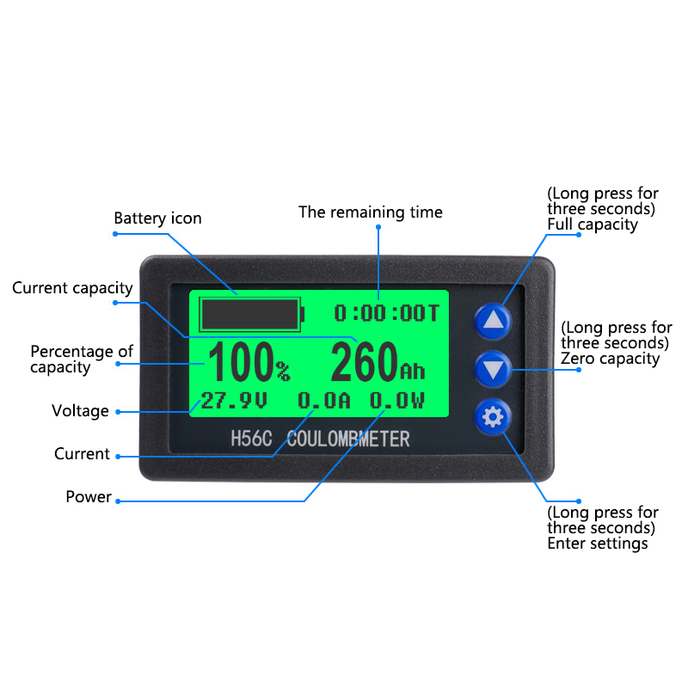
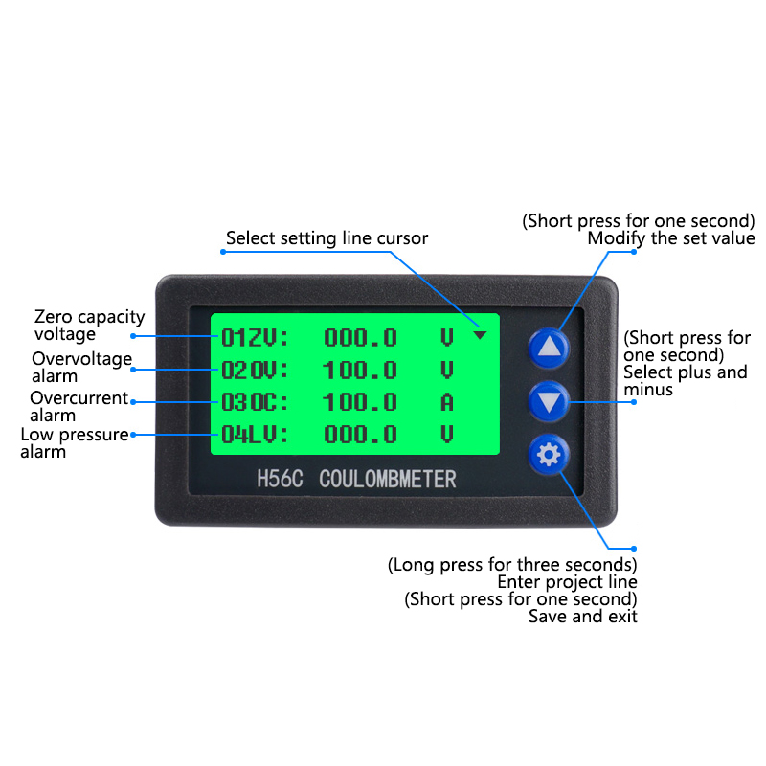
Installation Instructions
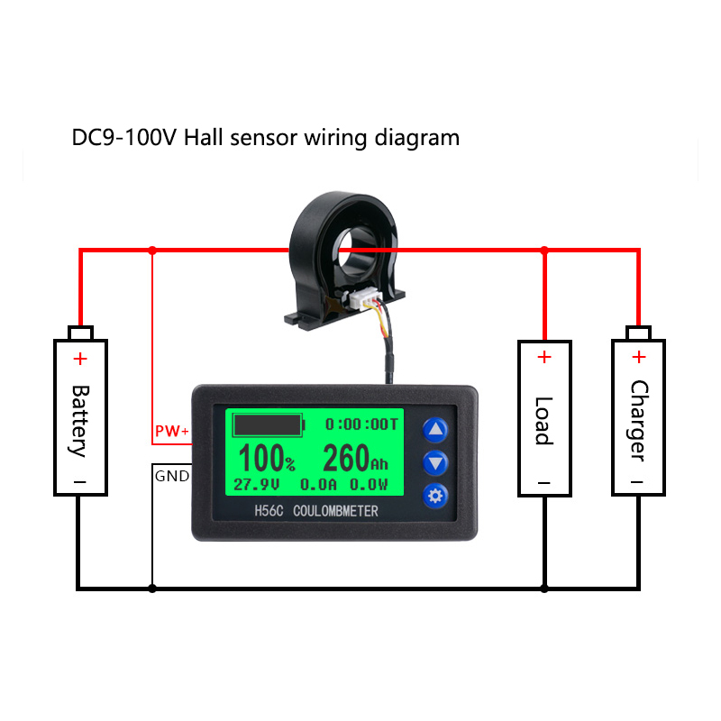

Installation method
Note: Please follow the wiring diagram strictly, the coulomb counter must be connected to the negative circuit of the battery, and it is strictly prohibited to connect to the positive circuit!
It is fixed by a buckle, which is easy to install. Open a rectangular hole on the panel of your device according to the size, place the coulomb counter in the rectangle, and press hard to make the buckle fasten. As shown below

Steps to use automatic mode
(This mode is simple to use, it is recommended that you use automatic mode)
Wire and check the current: all the wires of the positive (or negative) terminal of the battery pass through the sensor for measurement. The correct wiring is that the coulomb counter displays positive current when charging, and negative current when discharging. If it is not, it means that your sensor is connected upside down. You can turn the sensor in reverse; If the current of a newly installed coulomb counter is not at no load, If it is zero, the current needs to be cleared under no-load conditions.
Battery capacity reset: The capacity value displayed by the battery gauge after the first use or replacement of the battery is not the actual value of the battery. Zero capacity operation is required: After the battery is empty (empty), press and hold the button for 3 seconds, and the capacity value and
percentage are cleared When the battery is charged at this time, the capacity will automatically display 100% after being fully charged. This process is completely automatic and does not require customer settings, which is simple and convenient.
Special case: After the battery is fully charged by the charger, the capacity does not display 100%, you can press and hold the up button to manually fill it to 100% (Note: Long press the up button without unplugging the charger)

Manual mode use steps
(This mode is used when the customer knows the battery characteristics very well)
Wiring and checking the current: All wires of the positive (or negative) terminal of the battery are measured through the sensor. The correct wiring is that the coulomb counter displays positive current when charging, and negative current when discharging. If it is not, it means that your sensor is connected upside down. You can turn the sensor in reverse; If the current of the newly installed coulomb counter is not zero when there is no load, the current needs to be cleared when there is no load.
Setting parameters: The two parameters of the battery rated capacity CA and the fully charged automatic capacity voltage FV must be set. The rated battery capacity is set in the menu item: 11CA (effective battery capacity); Fully charged and automatically top up the capacity voltage in the menu item: 12FV (full capacity voltage) set (this voltage is recommended to be set to the highest virtual battery voltage displayed by the coulomb counter when the battery is fully charged and the charger is not unplugged) .
Fully charged once: After connecting the cable and setting the parameters, the meter will not display the battery capacity immediately. At this time, the battery icon and capacity are still empty, and the battery needs to be fully charged once to be normal. The remaining power is often displayed, which requires special attention.
For example: My battery has a rated capacity of 20AH and the maximum virtual voltage of a fully charged battery is 56V. How should I set it?
Answer: Set the parameter in the 11CA menu to: 20.0AH, and set the parameter in the 12FV menu to: 56.0V.

Precautions and warranty
The coulomb counter should not be exposed to the sun for a long time, nor can it be exposed to extreme conditions below -20°C and above 60°C for a long time, otherwise the life of the LCD screen of the display will be shortened.
Details Images
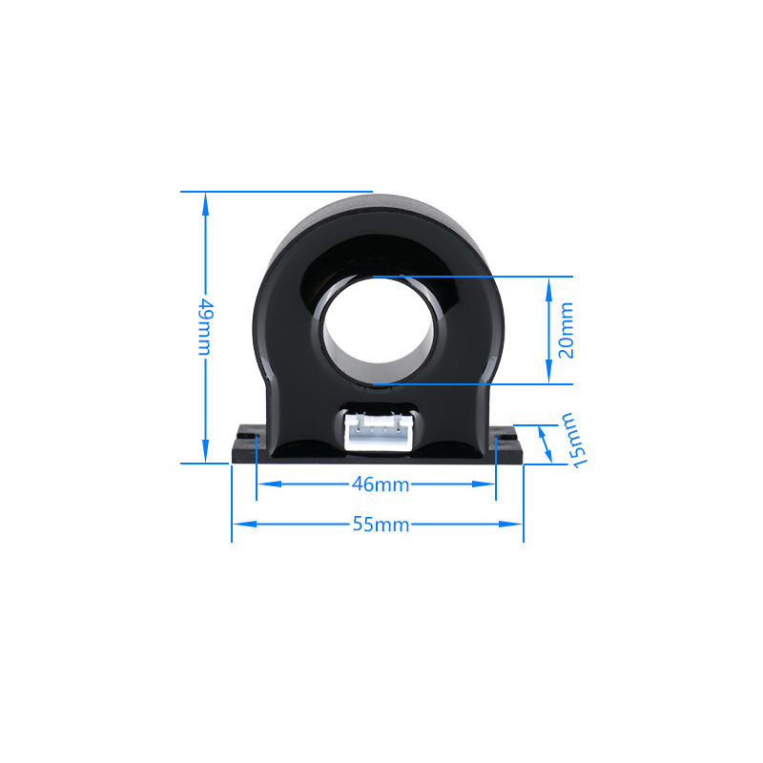
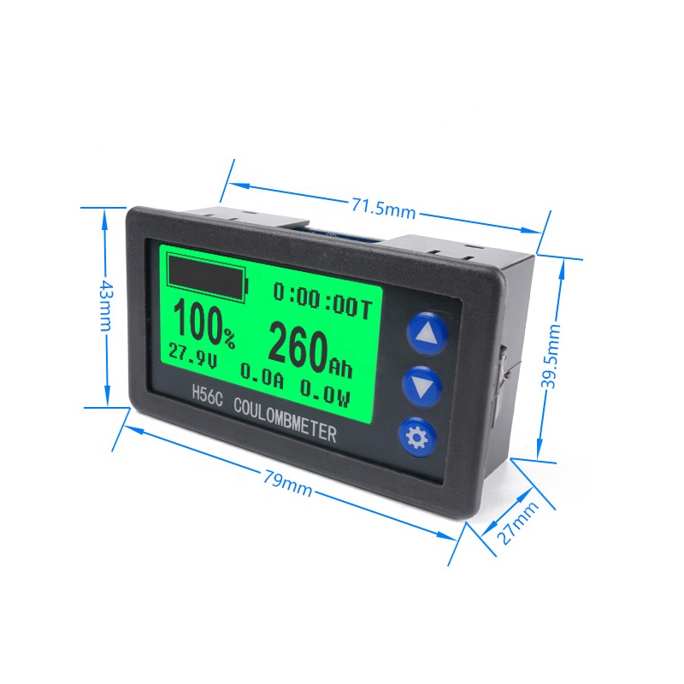
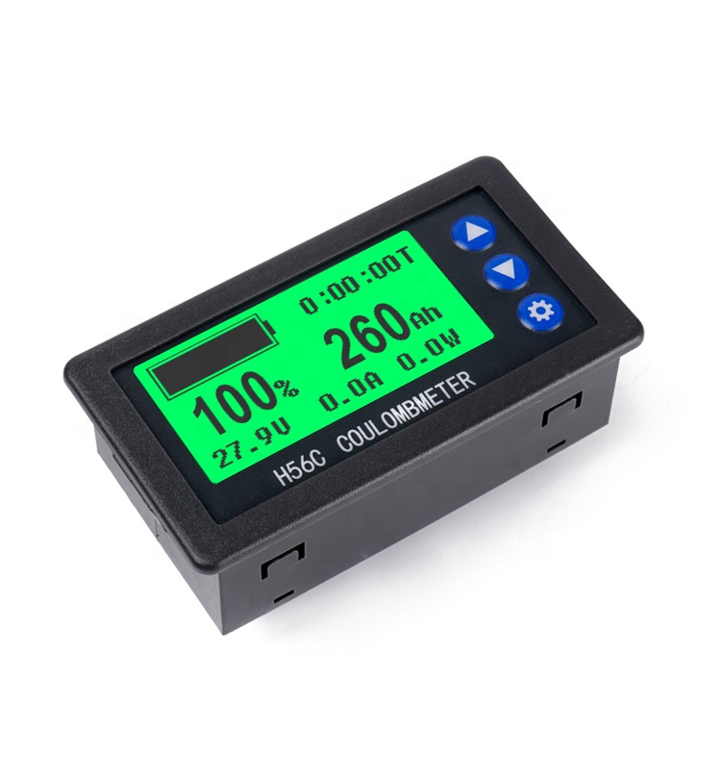
Packing & Delivery

